Christine Singleton
Assignment Enacted: March 12, 2025
Created for ENGL 102
Writing Thick Description Practice

- Activity Sequence:
  - Pick a partner within your group
  - Choose a photo in your phone. The photo must be appropriate for school and must include more than one person
  - Upload your photo to the Discussion Board
  - Using the questions below, write and comment a “thick” description of the photo your partner uploaded. 10-sentence minimum
    - First Glance Questions:
      - What is the layout of the room or space?
      - What are the specific objects or physical elements in the space?
      - What are the people you are observing doing in general or attempting to accomplish?
      - What are people wearing?
      - What is their affect, or demeanor, like?
    - Deeper Meaning Questions:
      - What clues signify people’s statuses and roles? Are they wearing something special? For example, in my photo you can see people wearing graduation gowns. This symbolizes that they are graduating students.
      - What clues signify the people’s relationship to each other? Are they hugging or smiling at each other? How are they interacting with each other?
    - Hypothesizing Conclusions Questions:
      - Now, drawing on everything you have observed, what can you assume to be true about the situation you have observed?
      - What themes can you draw from what you have observed?
      - Can you situate the photo? By this I mean, can you place it in a specific time or place? Where does the photo take place?
      - What explicit structures, rules, or norms govern the situation? For example, because we can assume that my photo was taken at a graduation, or related activity, we know that the people in the photo should be quiet and respectful during the graduation ceremony.
My Example to Students:


Student Sample:
Student 1: 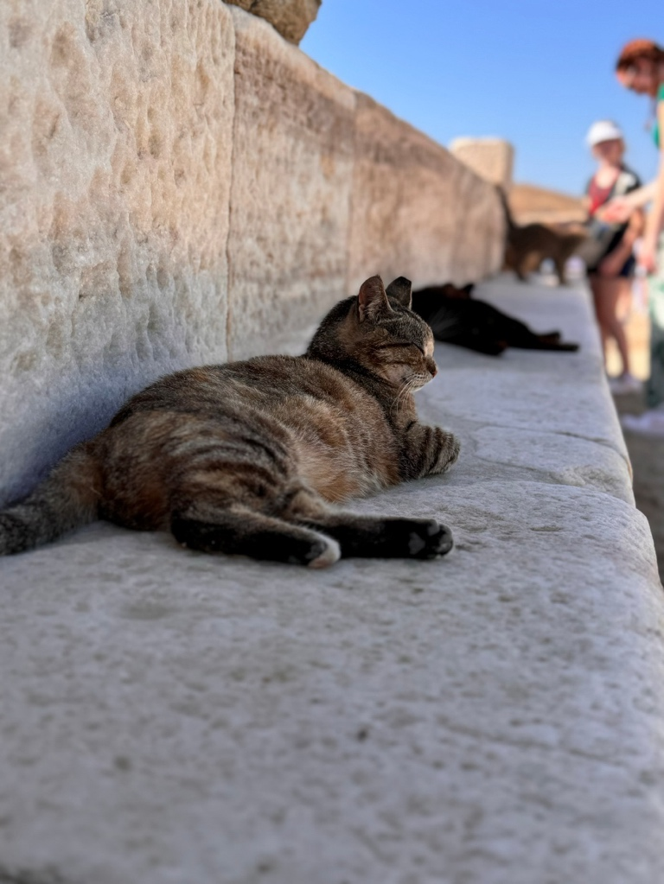
Student 2: In this photo, the main subject is a multicolored cat sitting on stone steps with his eyes closed. Next to him, a black cat lays out unbothered while another cat is interacting with two women. The cat has his back arched and he is being pet by a woman with red braids while another woman is watching while wearing a visor. The main cat has his front paws tucked under his chest and looks so soft and calm but may have a bite in his ear. The steps the cats are on are big and look like granite or maybe just stone steps that are shaded by the step above. It seems as if the steps do not continue and this is simply a 'cat bench'. You can tell that the woman playing with the cat is smiling and joyous. The black cat in the middle watches as the other cat is being pet. It is a sunny day and. the cats find shade in this area close to tourists. Perhaps the cats were there before the people showed up beacuase they look like free street cats that do whatever they want and are not owned by anyone. The cats do not have collars. The main cat makes me smile, it is adorable and I love cats, I wonder if there are more cats around this area. What makes these wild cats come to this specific spot? and where specifically is this?

